SDLC METHDOLOGIES
This document play a vital role in the development of life cycle (SDLC) as it describes the complete requirement of the system. It means for use by developers and will be the basic during testing phase. Any changes made to the requirements in the future will have to go through formal change approval process.
SPIRAL MODEL was defined by Barry Boehm in his 1988 article, “A spiral Model of Software Development and Enhancement. This model was not the first model to discuss iterative development, but it was the first model to explain why the iteration models.
As originally envisioned, the iterations were typically 6 months to 2 years long. Each phase starts with a design goal and ends with a client reviewing the progress thus far. Analysis and engineering efforts are applied at each phase of the project, with an eye toward the end goal of the project.
The steps for Spiral Model can be generalized as follows:
- The new system requirements are defined in as much details as possible. This usually involves interviewing a number of users representing all the external or internal users and other aspects of the existing system.
- A preliminary design is created for the new system.
- A first prototype of the new system is constructed from the preliminary design. This is usually a scaled-down system, and represents an approximation of the characteristics of the final product.
- A second prototype is evolved by a fourfold procedure:
- Evaluating the first prototype in terms of its strengths, weakness, and risks.
- Defining the requirements of the second prototype.
- Planning an designing the second prototype.
- Constructing and testing the second prototype.
- At the customer option, the entire project can be aborted if the risk is deemed too great. Risk factors might involved development cost overruns, operating-cost miscalculation, or any other factor that could, in the customer’s judgment, result in a less-than-satisfactory final product.
- The existing prototype is evaluated in the same manner as was the previous prototype, and if necessary, another prototype is developed from it according to the fourfold procedure outlined above.
- The preceding steps are iterated until the customer is satisfied that the refined prototype represents the final product desired.
- The final system is constructed, based on the refined prototype.
- The final system is thoroughly evaluated and tested. Routine maintenance is carried on a continuing basis to prevent large scale failures and to minimize down time.

The following diagram shows how a spiral model acts like:

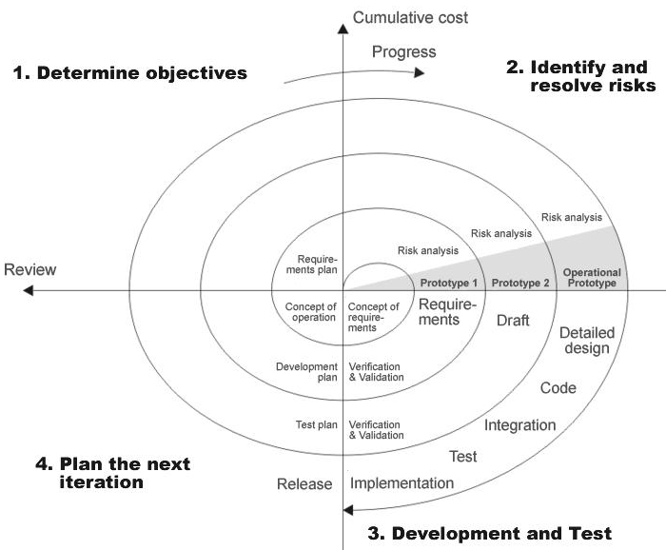

Fig 1.0-Spiral Model

